To add a Hotcall manifest select Reports|HotCall ASN(856)…

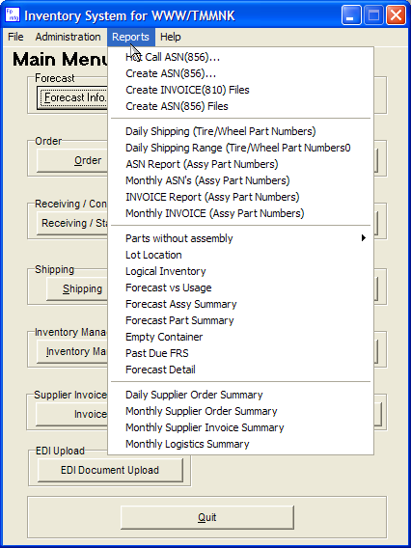

The Hotcall entry dialog appears

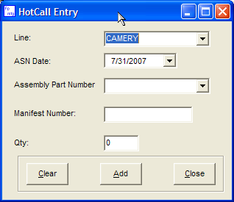

- Select the correct line, in your case there is only one line.

- Select the ASN date

- The drop down contains all possible Assembly Part Numbers, select one.

- Enter the Manifest number, it must be 8 digits.

- Enter the amount

To insert the entry into the Inventory database press add. To cancel, press clear or close to exit the form.

After you have entered all of the Hotcall part numbers the ASN files can be created using the same Reports|Create ASN(856) Files function that is used for all other ASN files.

The ASN can also be edited, deleted, or resent using the same functions in the ASN/Invoice form that are used for other ASNs.

